**Getting Started with PEST++ and SWMM**

**Faryn Dumont and Michelle Simon**

**United States Environmental Protection Agency**

**Similar to https://www.ndsu.edu/pubweb/~zhulin/pdf/teaching/starting%20pest.pdf**

**Date**

1. Download PEST++ <https://pesthomepage.org/software-0>
2. Path PEST - Got to search and type “env”  <https://www.architectryan.com/2018/08/31/how-to-change-environment-variables-on-windows-10/>
3. Run model *.inp; to produce
   1. *.rpt;  N.B. The SWMM *.rpt ASCII File is analogous to the ASCII output file in the PEST Manual
   2. *.out;
   3. *.ini files
4. Organize storm, inflow, outflow, and calibration data files into *.obj. The calibration data files must be in the format of the time series file.
5. Make files
   1. Batch file – have swmm.exe, swmm.dll in the same directory or available via path
   2. Model input template files
      1. *.tpl,
      2. run tempchek
   3. Model output reading instruction files
      1. *.ins,
      2. run inschek
   4. PEST control file
      1. *.pst,
      2. run pestchek

PEST produces  OUTPUT FILES

1. Run Record (.REC) – covers objective function history, parameters history,  stats for residuals, groups, correlation
2. Residuals (.RES) and (.REI) - calculated and observed values for observations (including weighted value),  residuals
3. Sensitivities – Parameters (.SEN)
4. Sensitivities – Observations (.SEO)
5. Parameter files - *.PAR
6. Eigenvalue Matrix - *.MTT – covariance, correlation, eigenvector, eigenvalue matrices
7. Single value decomposition - *.SVD
8. Jacobian Matrix - *.JCO (binary file)

How to do double precision in SWMM

<https://social.msdn.microsoft.com/Forums/en-US/7e2a5fa2-21f1-4d64-8263-d23fbe1383b5/how-to-set-precision-for-double-value>

<https://ocw.un-ihe.org/pluginfile.php/521/mod_resource/content/1/Urban_Drainage_and_Sewerage/8_Modelling_Urban_Drainage/SWMM5/SWMM5%20Quick%20start/SWMM%20QUICK%20START%20TUTORIAL.pdf>



PEST + SWMM

<https://blog.iseesystems.com/modeling-tips/calibrate-models-pest/>

<https://stackoverflow.com/questions/14845937/java-how-to-set-precision-for-double-value>

Download PEST

Path PEST

Got to search and type “env” <https://www.architectryan.com/2018/08/31/how-to-change-environment-variables-on-windows-10/>

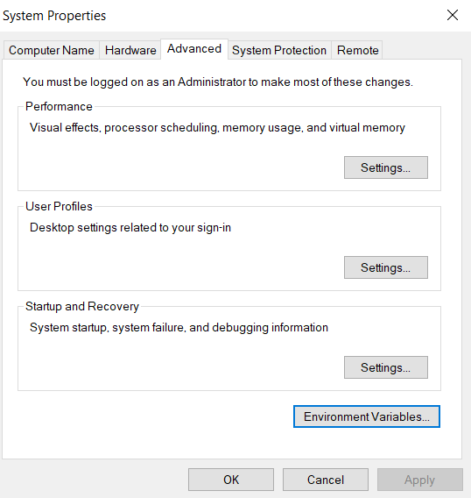

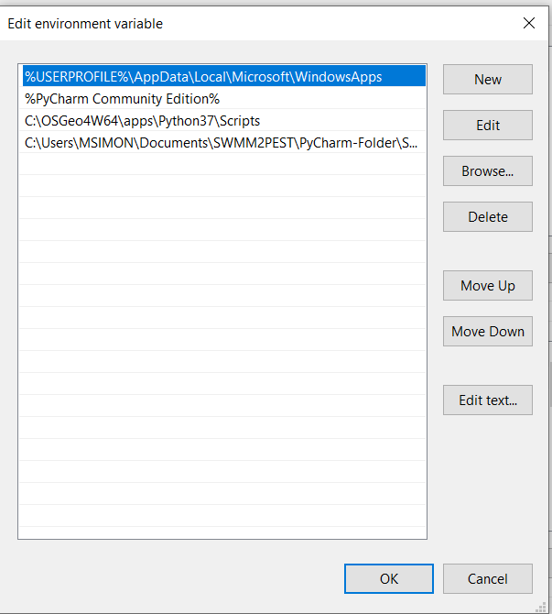

To run PEST

1. Model Batch File *.bat

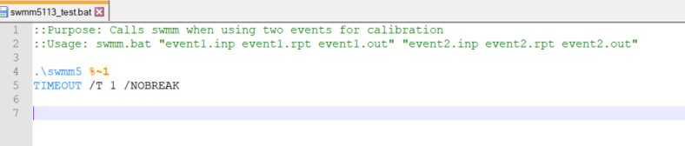

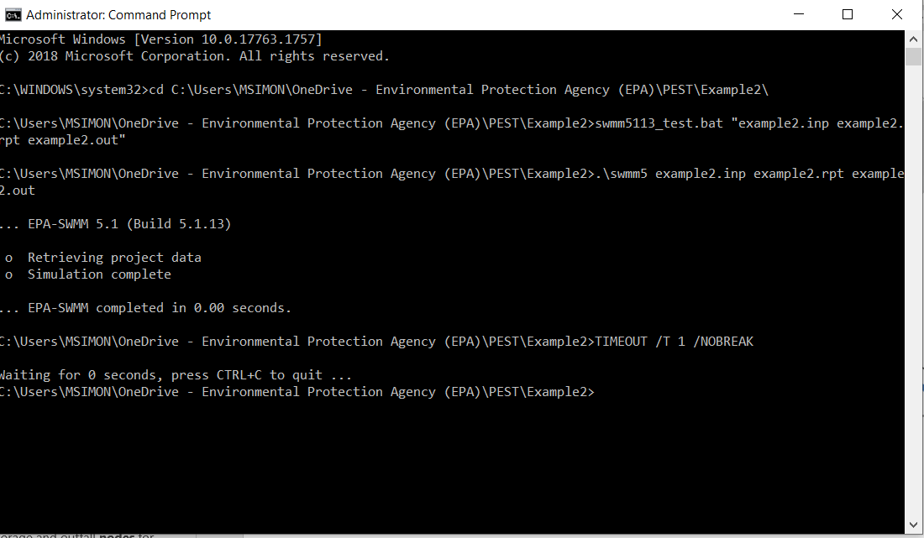

1. SWMM input template files  *.tpl, run tempchek

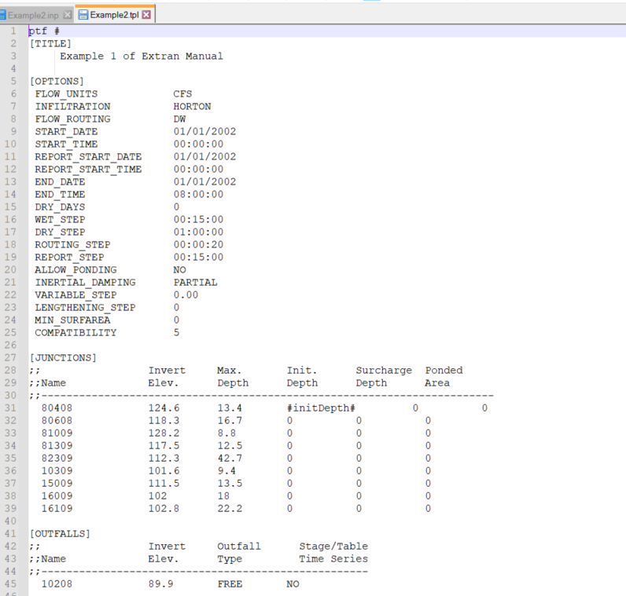

Run tempchek

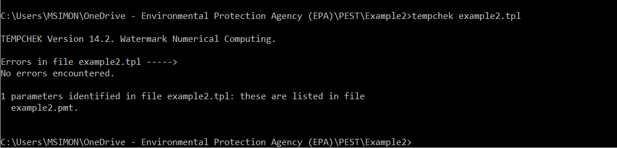

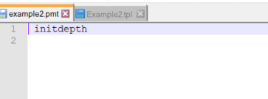

1. Model output reading instruction files *.ins, run inschek

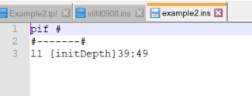

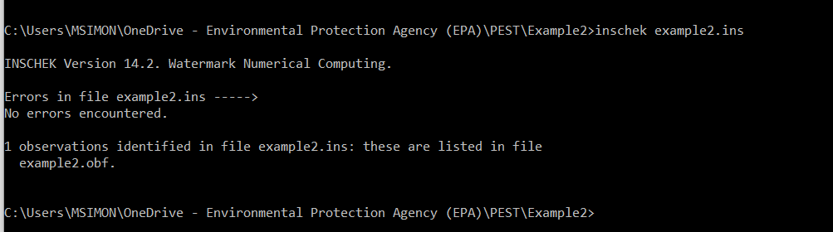

1. PEST control file *.pst, run pestchek